BOOKENDS HOSPITALITY PVT. LTD.
Internal Operations — Regulatory Readiness Series

FSSAI Schedule 4 & FDCA Compliance Readiness Report

Central Hot Kitchen — Ahmedabad, Gujarat

Outlet / Brand | Central Hot Kitchen
Location | Ahmedabad, Gujarat
Business Category (presumed) | BOOKENDS HOSPITALITY PVT. LTD.
Inspection / Audit By | Vishal Patel
Report Prepared By | Vishal Patel

Ref | Priority | What the evidence shows
S1 ★ | Critical | Not available
K19 ★ | Critical | A pest (cockroach) was photographed on the floor on the audit day, despite this checkpoint being scored 2. The pest-control certificate on file is addressed to a different business name and had already lapsed for over a  year.
K15 ★ | 1 evidence | Fitness certificates not available.

Ref | Checkpoint | Rating | Priority | Remark
S1 ★ | FSSAI licence displayed and valid; Food Safety Display Board put up | 0 | Major | Not available

S10 | Drinking water potable/filtered; dispenser and jug clean | 2 | Compliant | 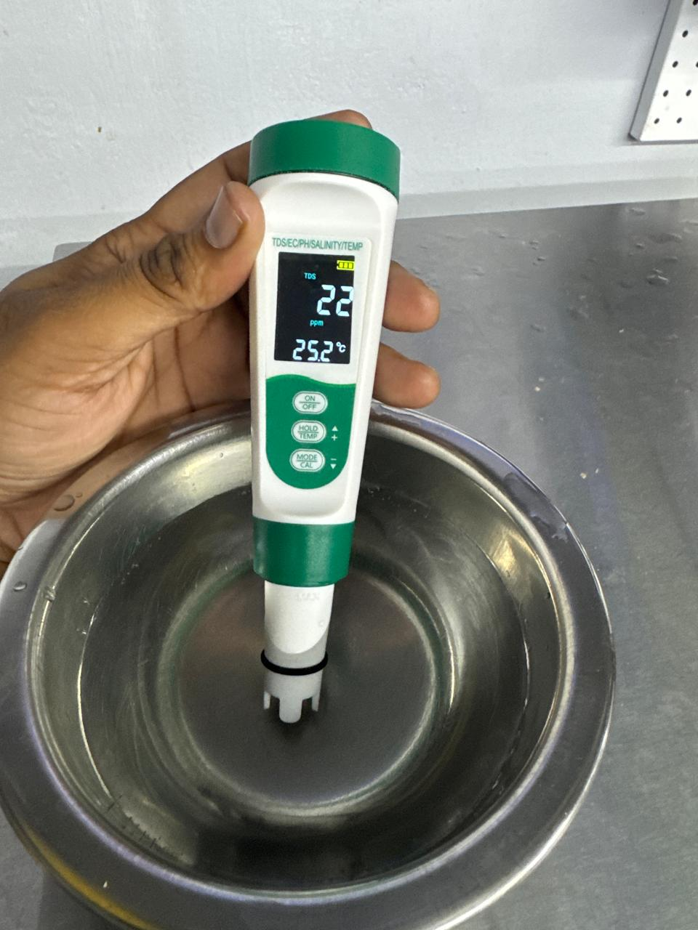
S13 | Restrooms clean and stocked; doors do not open directly into food area | 2 | Compliant | —
K18 | Hand wash stations stocked — soap, sanitizer, paper towel | 2 | Compliant | —
K20 | Drain traps in place, flowing and clean; no standing water | 2 | Compliant | 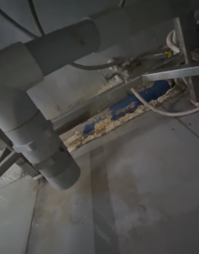

Ref | Checkpoint | Rating | Priority | Remark
K1 ★ | No expired or undated items anywhere on the premises | 0 | Major | 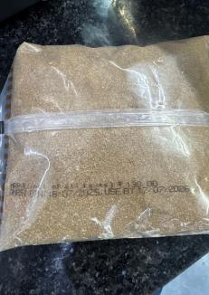  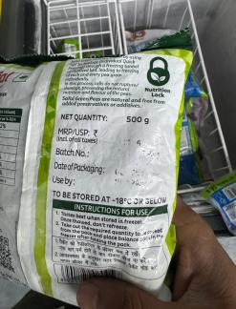  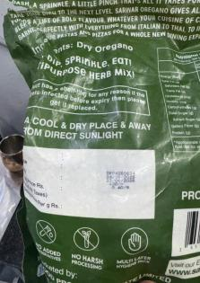
Ref | Checkpoint | Rating | Priority | Remark
K2 | Decanted containers labelled with name and date; FIFO followed | 0 | Major | 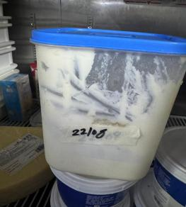  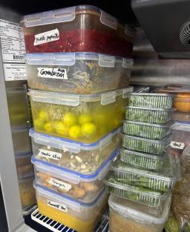
K4 ★ | Raw and cooked food completely segregated | 2 | Compliant | —
K5 ★ | Veg segregated in storage and prep | 2 | Compliant | —
K6 ★ | Chiller ≤ 5°C, freezer − 18°C; temperature log up to date | 2 | Compliant | —
K7 | Hot holding ≥ 60°C; cooking to a core temperature ≥ 75°C | 2 | Compliant | —
K8 | Thawing only under refrigeration — never at room temperature | 2 | Compliant | —
K14 | Only approved colours/additives used; declaration on file | 2 | Compliant
K19  ★ | No pest activity; pest-control service record up to date; stations mapped | 0 | Major | No record

Ref | Checkpoint | Rating | Priority | Remark
S12 | Waste bin covered, foot-operated, not overflowing | 2 | Compliant
K9 | Chemicals labelled not mention and stored away from food | 2 | Compliant
K21 | Waste segregated, bins covered, emptied daily | 2 | Compliant
S4 | Floors, walls, ceiling clean — no cobwebs, seepage or flaking paint | 0 | Major | 
K22 | Exhaust and hoods degreased; ventilation adequate; lights protected | 1 | Partial | 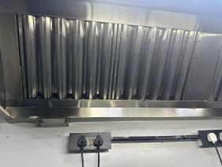
K3 | Storage 15 cm off the floor; no cartons or food on the floor. | 2 | Compliant | —
K11 | Colour-coded boards / separate prep tools in use | 2 | Compliant | —
K12 | Frying oil within TPC limit; oil-change log up to date | 2 | Compliant

S7 | No unwell staff on duty; cuts/wounds covered with waterproof dressing | 2 | Compliant
K15 ★ | Medical fitness certificate up to date for every food handler | 0 | Major | Not available
K17 | Kitchen staff — cap, apron, trimmed nails, no jewellery; no smoking or paan | 0 | Major | 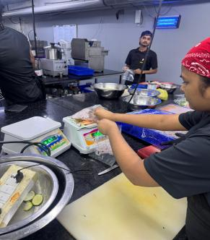  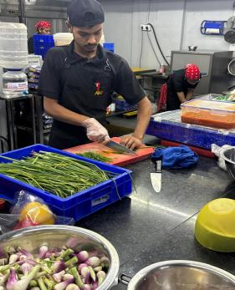
K16 | FoSTaC-certified supervisor on roster; certificate available | 0 | Major | Not available
K23 ★ | Water potability report valid  — tested within the last 6 months | 0 | Major | Team reports an informal daily check is done, but there is no documented report; the formal 6-monthly lab report has not been renewed.
K24 | Deep-cleaning schedule up to date and followed; dispense log with temperature (CK checklist) | 0 | Major | No Record

K13 | Food-contact surfaces and equipment clean — no rust, damage or wooden patches | 2 | Compliant | —
K10 | Dry store clean, ventilated, pest-free. | 2 | Compliant

Score & Grade
Section | Available marks | Obtained marks | %
A — Kitchen Area | 76 | 45 | 59.2%
Total (Overall) | 76 | 45 | 59.2%

Conclusion
- Overall standing — 45/76 (59.2%) for the kitchen area — Needs Improvement. 5 of the 8 ★ criticals are Non-Compliant (S1, K1, K15, K19, K23); K4, K5, K6 pass.
- Operational control is largely sound — K6 passes, so the chiller and freezer temperatures and the temperature log are in order, and so are raw/cooked and veg segregation (K4, K5), chemical storage (K9), the dry store (K10) and waste handling (K21). The losses sit in the licence (S1 ★), stock dating (K1 ★, three photographs), decanted container labelling (K2), staff grooming (K17), premises condition (S4), extraction (K22, partial) and the records set (K15 ★, K16, K19 ★, K23 ★, K24).
- Four items from Satisfactory — the five failing ★ criticals (S1, K1, K15, K19, K23) carry 20 marks between them; closing any four of them reaches 61/76 (80.3%), and all five reaches 65/76 (85.5%) — comfortably inside the Satisfactory band.

